User Guide

jWebSocket
JMXPlugIn
1.0

1. Solution Characteristics
JMXPlugIn provides centralized and remote management of the applications developed with the jWebSocket framework. This plugin is developed using the Java native technology, JMX (Java Management Extensions). This technology is considered a standard that provides the tools for building distributed, modular and dynamic solutions for management and monitoring of devices, applications and networks. JMXPlugIn implements the architecture specified for this technology which is designed for building highly scalable management solutions. Thereby JMXPlugIn module provides the functionalities needed to efficiently manage the jWebSocket Server resources.
Through JMXPlugIn can be remotely invoked the functionalities of the applications running on a given jWebSocket Server. This fact allows a centralized control and monitoring of services, devices and applications developed using jWebSocket framework, greatly simplifying the complexity in managing them. Moreover, this module allows to remotely managing certain features of jWebSocket server ensuring the availability and proper operation of the resources. In order to provide greater flexibility to developers using the jWebSocket framework, JMXPlugIn provides a simple mechanism for the integration of separate management solutions. This module allows remote access to all functionalities through RMI and HTTP protocols, allowing the administrator comfort and providing greater flexibility and usability to the solution. Furthermore, with the objective of ensure application security, JMXPlugIn presents an authentication module using MD5 encryption algorithm and communication through a secure protocol.
2. Main Features
The JMXPlugIn module provides mainly the following features:
- Remotely invoke functions of the applications that are running on a given jWebSocket Server.
- Remotely manage certain features of jWebSocket Server.
- Remotely management functionalities of the applications developed with jWebSocket framework.
- Control of the remote access of users to the module.
JMXPlugIn as a management tool for jWebSocket framework and server allows monitoring and control resources centrally and remotely. To be developed based on JMX, Java native technology, offers a natural, efficient and lightweight solution that simplifies the management process in this framework. Also presents a highly scalable architecture that allows the management of resources with minimal impact on its design. In summary, JMXPlugIn is designed for efficient and flexible management of the services, devices and applications developed with jWebSocket framework.
3. Problems to be solved
Problem | Contributions of the solution
Deficiencies in the process of remote administration of jWebSocket Server resources. | JMXPlugIn provides a set of generic features that enable centralized control and monitoring of resources managed by jWebSocket Server. It also allows remote access to all these features through RMI and HTTP protocols, providing greater flexibility and usability to the solution.
Complexity in the management process of the applications running on jWebSocket server. | JMXPlugIn enables integration of applications developed using jWebSocket framework, enabling a centralized management of them and simplifying this process.
4. Glossary
Remote Management: is the set of activities, methods, procedures and tools to ensure effective and efficient operation of a networked system, avoiding the deployment of staff or devices on the location of the components or distributed resources.
JMX: standard that provides the tools for building distributed, modular and dynamic solutions for management and monitoring of devices, applications and networks.
jWebSocket Framework: is a new technology aimed at developing WebSockets based applications that provide high levels of speed, scalability, security and real-time work.
WebSocket: technology that provides a bidirectional and full-duplex communication channel over a single TCP socket. This protocol solves the limitations of HTTP, by establishing a full-duplex communication (TCP) between the client and server, replacing the half-duplex communication (HTTP).
Full-Duplex: quality of the elements that allow the input and output of data simultaneously.
Socket: method for communication between a client program and a server program on a network.
Half-Duplex: bidirectional, but not simultaneous, method or protocol for sending information.
MD5: is a cryptographic algorithm reduction of 128 bits. It is a hash encryption function that accepts a string as input and returns a 128 bit number. This algorithm is used to transmit passwords through insecure media.
MBean: In the Java programming language, an MBean (managed bean) is a Java object that represents a manageable resource, such as an application, a service, a component, or a device.
MBeanServer: is the core component of the JMX Agent infrastructure. The MBean server is a registry for MBeans in the Agent layer of JMX architecture. The MBean server is the component that provides the services for manipulating MBeans. All management operations performed on the MBeans are done through the MBeanServer interface.
5. Solution Model

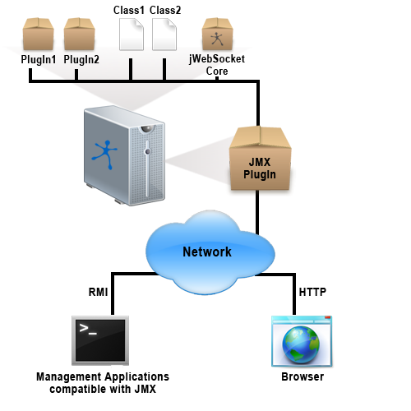
Fig. 1 Communication diagram of JMXPlugIn module.
JMXPlugIn is part of jWebSocket server thus enabling more efficient management of managed resources. Remote access to the module can be done through RMI and HTTP protocols. To access using the RMI protocol you must have a JMX-compliant management application such as JConsole tool. On the other hand, if you want access to the module via the HTTP protocol only is necessary to have a browser. In both cases, the user must authenticate to get full access to the functionalities provided by JMXPlugIn.

6. Use Requirements
For proper operation of JMXPlugIn you should take into account the following aspects:
- OpenJDK 1.7 or higher installed.
- Ports 8080, 1099 open and unused.
- Web browser to access thought HTTP protocol.
- JMX-compliant management application to access thought RMI protocol.
7. Main Roles
Administrator: Able to perform all the actions provided by JMXPlugIn.
8. Operation of the system
The access to JMXPlugIn using the RMI protocol can be performed using any management tool compatible with JMX. In this case, we show an example of how to work with the module using the JConsole tool, which comes installed by default in JDK since version 1.5. The JConsole executable is located in %JDK_HOME%/bin. If this directory is registered in the system path, you can start the tool by simply typing jconsole command at the shell prompt. Otherwise, you must type the full path to the executable file.
In the initial view of JConsole (see Fig. 2) is shown by default a window to connect with the desired process. This process can be both local and remote. To establish a new local connection with the process belonging to the JMXPlugIn module, you must select the Local Process option in the panel number 1. Then you must select the org.jwebsocket.console.JWebSocketServer process and press the Connect button (see Fig. 2). On the other hand, if you want to establish a remote connection with JMXPlugIn you must select the Remote Proccess option in the panel number 2. Then you must specify the URL for access to the module, which consists of the following elements:
service:jmx:rmi:///jndi/rmi:/mydomain.com:1099/jmxPlugin
In this case you must specify the username and password to access the module in the corresponding Username and Password fields. Finally, you must press the Connect button (see Fig. 2).
If you want to connect through a secure protocol using JConsole, you must run the following command at the shell prompt: “jconsole -J-Djavax.net.ssl.trustStore= truststore address” y “-J-Djavax.net.ssl.trustStorePassword= truststore password”. You must then select Remote Process panel number 2 and specify the URL for access to the module, which in this case consists of the following elements:
service:jmx:rmi:///jndi/rmi:/mydomain.com:1099/jmxPluginSSL
As in the previous case you must specify the username and password for access to the module and press the Connect button (see Fig. 2).

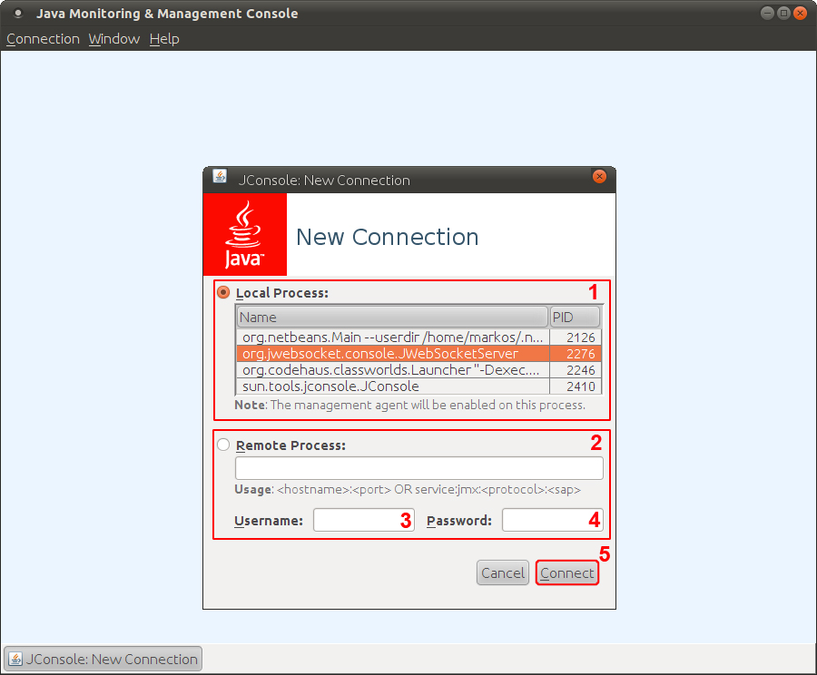
Fig. 2 Window to establish a new connection with JMXPlugIn.

1 – Panel that allows local access to Java processes running on the server.
2 – Panel that allows remote access to Java processes running on a given server.
3 – Field in which you must specify the user for remote access to the module.
4 – Field in which you must specify the password for remote access to the module.
5 – Button to make a new connection with the selected process.

After establishing the connection correctly shows the main window of JConsole. To access the functions of JMXPlugIn, you must select the MBeans tab located on the section number 1 (see Fig. 3). The section number 2 shows the MBeanServer for the JMXPlugIn module called jWebSocketServer. When you deploy jWebSocketServer, it will display all MBeans that are registered at that moment, thus allowing access to the functions mentioned above in the document (see Fig. 3).
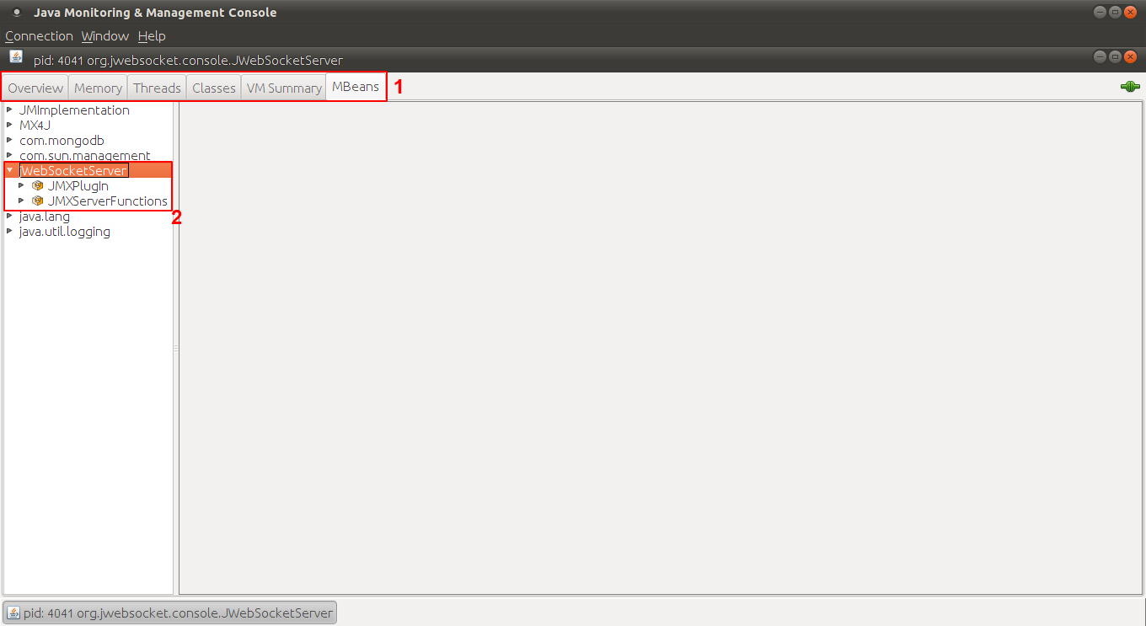
Fig. 3 MBeans tab view belonging to the main window of JConsole to JMXPlugIn process.

1 – Panel to select the different views of the main window of JConsole. In this case the tab selected is MBeans wich is required to display JMXPlugIn functionalities.
2 – Panel that displays the MBeans belonging to the JMXPlugIn module and access to their functionality.

By selecting the MBean called JMXPlugIn it will display the corresponding set of attributes, operations and notifications, on the panel number 1 (see Fig. 4). At the same time, in the section number 2 will display the information concerning to this MBean, as the class name, description, and others (see Fig 4). This MBean enables you to invoke the functionalities of the applications running on the jWebSocket server. It also displays information about this server.
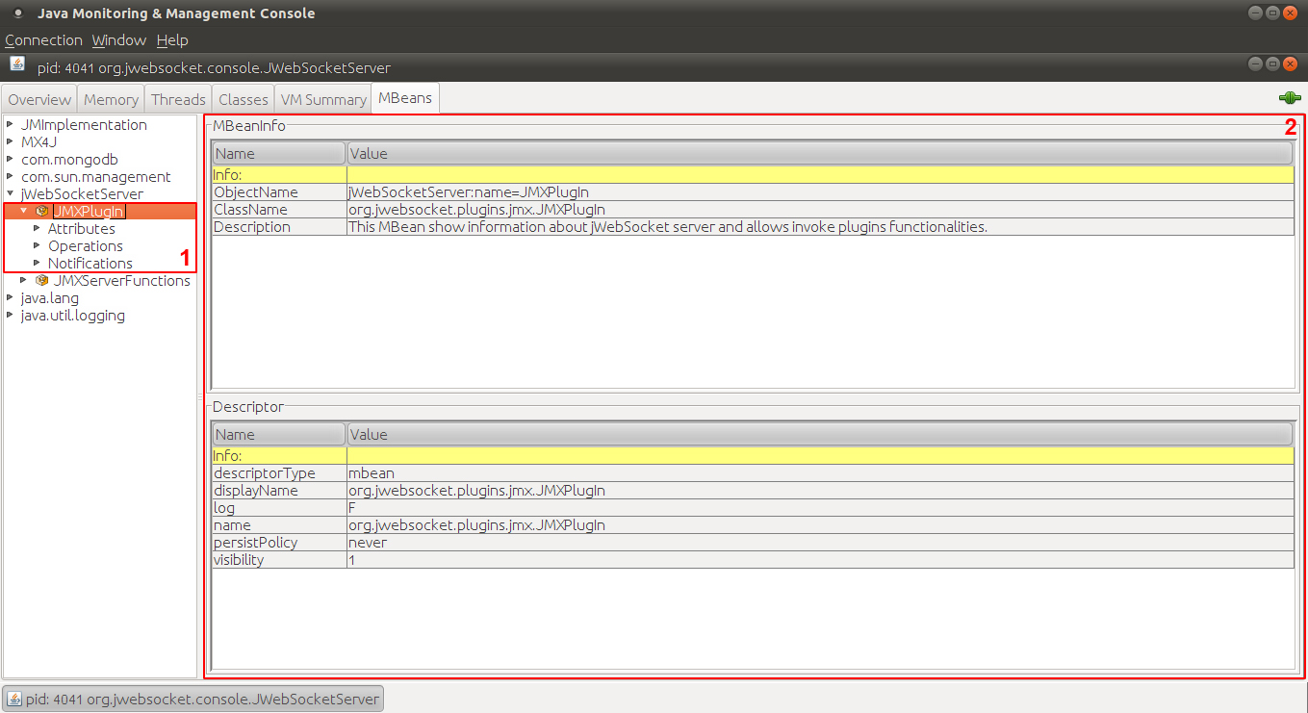
Fig. 4 JMXPlugIn MBean view.
1 – Panel to select the JMXPlugIn MBean properties in terms of attributes, operations and notifications.
2 – Panel that displays information about the JMXPlugIn MBean.
If you want to access to the attributes belonging to JMXPlugIn MBean you must select the Attributes element on the section number 1 (see Fig 5).Following it will display the list of attributes that in this case is only one, named InformationOfRunningServers. After you select this attribute it will display on the right side of the window two main panels. The panel number 2 corresponds to the information contained in this attribute. In this case it refers to the servers that are running at the time, and all information about the plugins that are running in each of those servers. Thus, the administrator will be aware of which plugins can be accessed at that time and which methods can be invoked. Moreover, in the panel number 3 it will displays information about the attribute itself, aspects such as the attribute name, description, corresponding data type, among others.
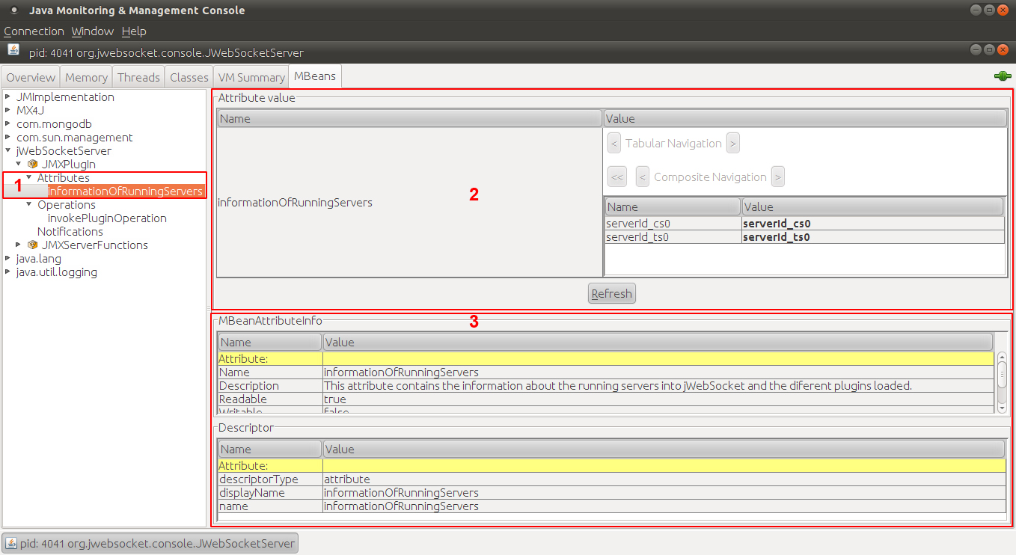
Fig. 5 Window that displays information of the attribute pertaining to the JMXPlugIn MBean.

1 – Section that shows the attributes belonging to JMXPlugIn MBean.
2 – Area that shows the information contained in the InformationOfRunningServers attribute belonging to the JMXPlugIn MBean.
3 – Area that shows the information corresponding to the InformationOfRunningServers attribute belonging to the JMXPlugIn MBean.
Moreover, if you desire to access the operations belonging to JMXPlugIn MBean you must select the Operations element in the section number 1 (see Fig. 6). Following it will display a list of operations in this case is only one, named InvokePlugInOperations. After you select this attribute it will display on the right side of the window two main panels. The panel number 2 corresponds to the operation itself, which displays the return data type, the parameters to enter and a button with the name of the operation which invoke it. The panel number 3 shows information about the operation allowing a better understanding of its purpose and requirements. Once invoked the operation a window will be show and its structure will depend on the data that need to be shown in each case (see Fig. 6).
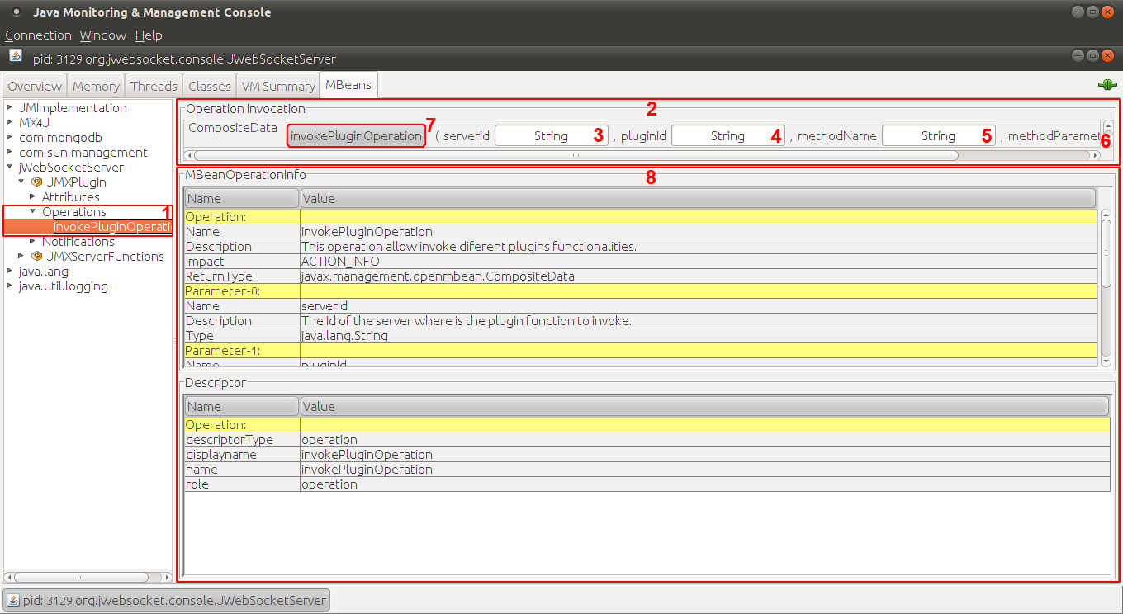
Fig. 6 Window that displays information of the operation pertaining to the JMXPlugIn MBean.

1 – Section that shows the operations pertaining to the JMXPlugIn MBean.
2 – Area that allows invoking the InvokePlugInOperations operation.
3 – Field in which you must specify the id of the server where is the plugin that has the functionality to invoke.
4 – Field in which you must specify the id of the plugin where is the functionality to invoke.
5 – Field in which you must specify the name of the method to be invoked.
6 – Field in which you must specify the parameters required by the method that you want to invoke.
7 – Button that allows invokes the functionality with the specified parameters.
8 – Area that shows information about the InvokePlugInOperations operation pertaining to the JMXPlugIn MBean.
When you select the MBean called JMXServerFunctions it will be displayed on the panel number 1, the correspoonding set of operations and notifications (see Fig. 7). At the same time, in the section number 2 it will display all the information concerning of this MBean, such as the class name, description, and others (see Fig 7). This MBean allows invoke certain features of the jWebSocket server.
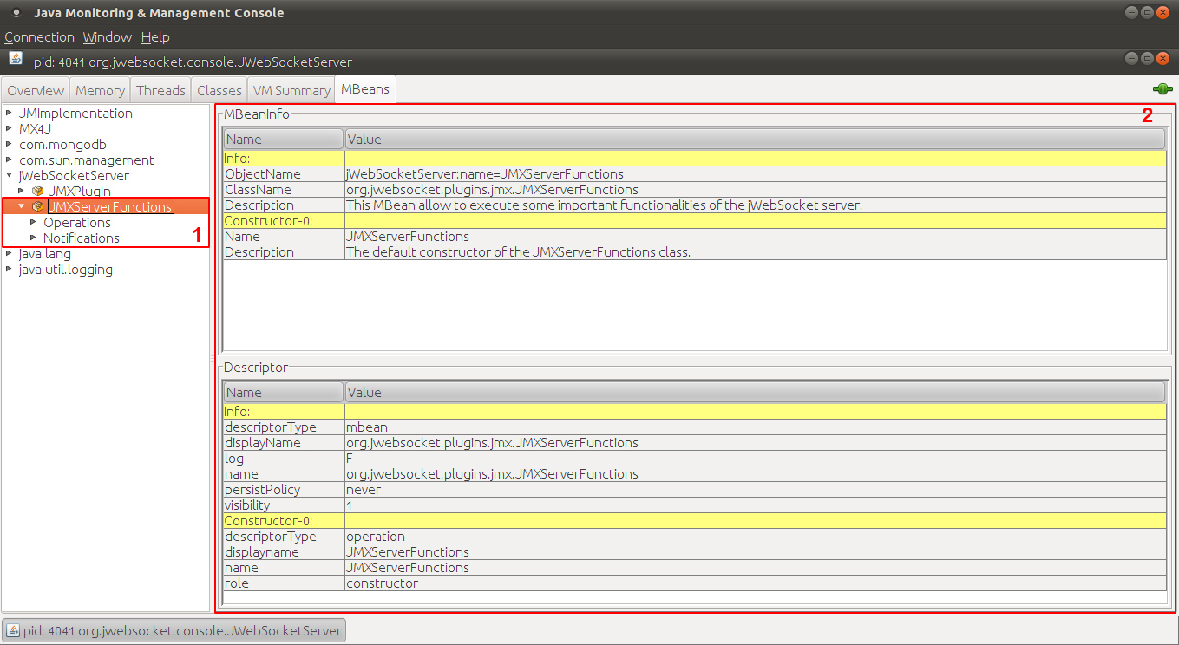
Fig. 7 JMXServerFunctions MBean view.

1 – Panel to select the different properties of the JMXServerFunctions MBean such as operations and notifications.
2 – Panel that displays information about the JMXServerFunctions MBean.
If you desire to access the operations belonging to JMXServerFunctions MBean you must select the Operations element in the section number 1 (see Fig. 8).Next on the panel number 2 it will display a list of all the operations that can be invoked. If you want access to the information regarding to any of these operations you must deploy the Operations tab in the panel number 1 and select the desired one. To invoke any of the listed operations you must press the button of the desired one (see Fig. 8).
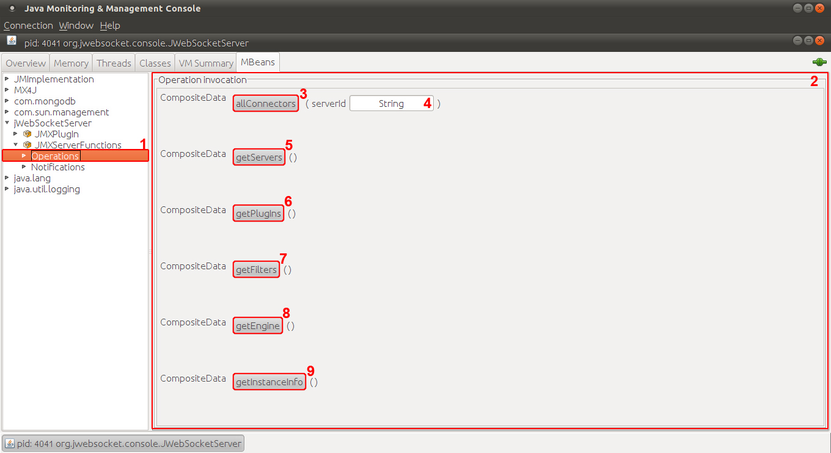
Fig. 8 View showing the list of operations of the JMXServerFunctions MBean.

1 – Panel to select the different operations of the JMXServerFunctions MBean.
2 – Panel which lists all the operations of the JMXServerFunctions MBean.
3 – Button to invoke allConectors functionality. This feature displays information of all existing connections on the jWebSocket server.
4 – Field in which you must specify the id of the server from which you want to know the existents connections.
5 – Button to invoke getServers functionality. This feature displays information about all servers that are running on given machine.
6 – Button to invoke getPlugIns functionality. This feature displays information about all the plugins that are loaded on the jWebSocket server.
7 – Button to invoke getFilters functionality. This feature displays information about all the filters that are running on the jWebSocket server
8 – Button to invoke getEngine functionality. This feature displays information about the engine which is running in jWebSocket server.
9 – Button to invoke getInstanceInfo functionality. This feature displays information about the machine that holds the jWebSocket server, taking into account the future implementation of clusters.

The features described above are the basic ones provides by JMXPlugIn module. However, this module also allows to the developers using jWebSocket framework integrate their plugins and classes in this infrastructure. In this case, would be shown also in Fig. 3 those MBeans that have been created by other developers. These MBeans have basically the same characteristics as those described above, but with the particularities of each solution.
If you want to add a plugin or class to the JMX infrastructure of the module you must include the appropriate configuration file in the PlugInsConfigFiles folder in the direction shown in Fig. 9.
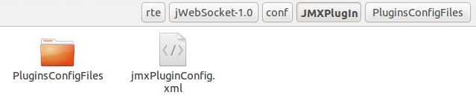
Fig. 9 Folder structure that contains the JMXPlugIn configuration files.

If PlugInsConfigFiles folder does not exist or is not in the address specified in Fig. 9, check the property "beans_config" in the jWebSocket.xml file which contains the address of this folder (see Fig. 10). For more information about the jWebSocket folder structure, you can access to the Folder Structure section.
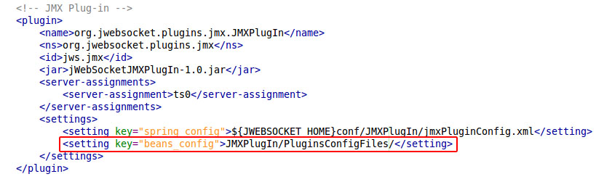
Fig. 10 Configuration for JMXPlugIn in the jWebSocket.xml file.
To correctly specify the class or plugin to export the configuration file name must be composed of the class or plugin name and the "BeanConfig.xml" suffix. For example if you want to export a class called Person, the configuration file name would be "PersonBeanConfig.xml". This file corresponds to the Spring configuration files, in this case defines a main bean as follows:
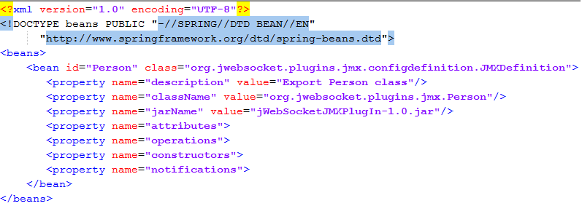
Fig. 11 Sample configuration file to export the class Person.
The id of the bean must match with the name of the class or plugin to export. In the class attribute must be specified the org.jwebsocket.plugins.jmx.JMXDefinition class if the item to export is a class or the org.jwebsocket.plugins.jmx.JMXPlugInDefinition class when it is a plugin. Then you must define the following properties:
- Description: contains a brief description of the item to export.
- ClassName: contains the full name of the item to be exported.
- JarName: contains the Java library where is included the item to export.
- Attributes: contains the attributes of the plugin or class to be exported. Later in this paper will be given a detailed description of this property.
- Operations: contains the operations of the plugin or class to be exported. Later in this paper will be given a detailed description of this property.
- Constructors: contains the constructors of the classes that will be exported, it isn´t necessary to define this property in case that the item to export is a plugin. Later in this paper will be given a detailed description of this property.
- Notifications: contains the notifications to be released on the occurrence of certain events in the plugin or class exported. In this case are defined the following events: when the value of an attribute change, before executing a method and after executing a method. Later in this paper will be given a detailed description of this property.
Furthermore if the item to export is a plugin must also specify the following properties (see Fig. 12):
- PluginId: contains the id for the plugin to be exported, this id must match with the one defined for the plugin in the "jWebSocket.xml" file.
- ServerId: contains the id of the server where is running the plugin to export, this id must match with the one defined for the plugin in the "jWebSocket.xml" file.
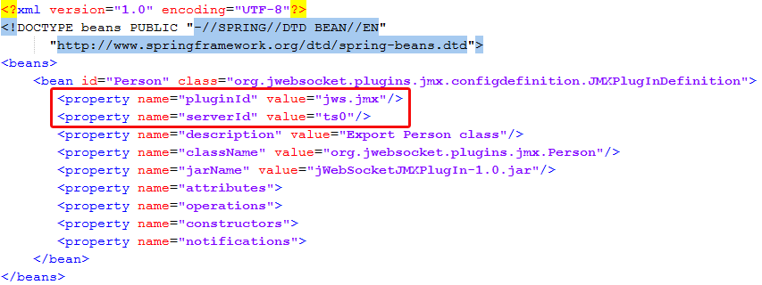
Fig. 12 Sample configuration file to export a plugin Person
The attributes property groups the set of attributes that you want to export as much of a class as a plugin. In the event that it is not desired export any attribute, this property must be completely removed from the configuration file. Below is an example of how you should define each of these attributes:
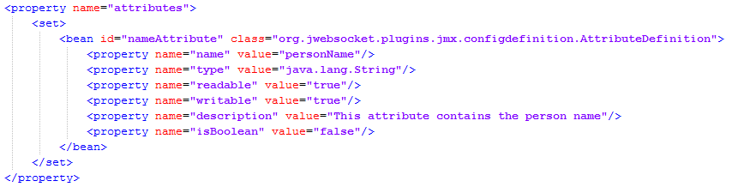
Fig. 13 Attributes property definition
For each attribute must be created a bean with an id given by the user and specify org.jwebsocket.plugins.jmx.configdefinition.AttributeDefinition in the class property. Then you must define the following properties:
- Name: contains the actual name of the attribute.
- Type: contains the data type of the attribute.
- Readable: contains a Boolean value indicating whether the attribute has defined a set method or not.
- Writable: contains a Boolean value indicating whether the attribute has defined a get method or not.
- Description: contains a brief description of the attribute to export.
- IsBoolean: indicates whether the attribute in question is Boolean or not.
The operations property contains all the operations that you wish to export from a class or a plugin. In the event that it is not desired export any operations, this property must be completely removed from the configuration file. Below is an example of how you should define each of these operations:
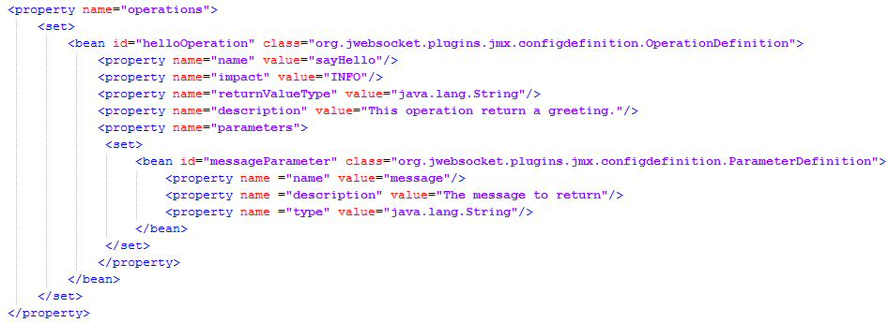
Fig. 14 Operations property definition
For each operations must be created a bean with an id given by the user and specify org.jwebsocket.plugins.jmx.configdefinition.OperationDefinition in the class property. Then you must define the following properties:
- Name: contains the actual name of the operation.
- Impact: indicate the type of action that will execute the operation. The types of actions accepted in this property are INFO, ACTION, ACTION_INFO and UNKNOWN.
- ReturnValueType: contains the data type returned by the operation.
- Description: contains a brief description of the operation to export.
- Parameters: contains the definition of the parameters required to run the operation. In the event that the operations don’t need any parameters, this property must be completely removed from the configuration file. Described below are the steps to set this property.
For each input parameters must be created a bean with an id given by the user and specify org.jwebsocket.plugins.jmx.configdefinition.ParameterDefinition in the class property. Then you must define the following properties:
- Name: contains the parameter name.
- Description: contains a brief description of the parameter.
- Type: contains the data type of the input parameter.
The constructor’s property contains the definition of the classes to be exported. This property can only be specified when you want to export a class. It should be noted also that even if it possible to define more than one constructor to a particular class, the implementation of JMXPlugIn is configured to build the class given the first constructor that is specified in the configuration file. Below is an example of how you should define each of these constructors:
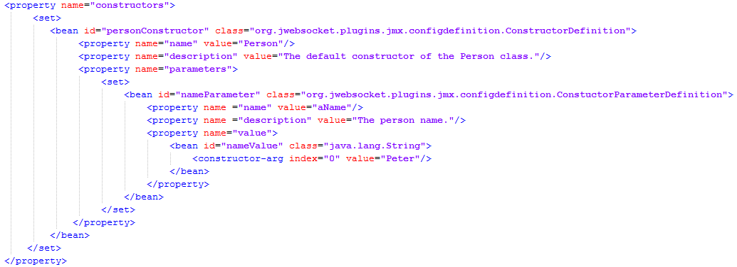
Fig. 15 Constructors property definition.
For each constructor must be created a bean with an id given by the user and specify org.jwebsocket.plugins.jmx.configdefinition.ConstructorDefinition in the class property. Then you must define the following properties:
- Name: contains the actual name of the constructor.
- Description: contains a brief description of the constructor.
- Parameters: contains the definition of the parameters needed to create an instance of the class. In the event that the constructor doesn’t need any parameters, this property must be completely removed from the configuration file. Described below are the steps to set this property.
For each input parameters must be created a bean with an id given by the user and specify org.jwebsocket.plugins.jmx.configdefinition.ConstructorParameterDefinition in the class property. Then you must define the following properties:
- Name: contains the actual name of the parameter.
- Description: contains a brief description of the parameter.
- Value: contains the parameter value. However for its correct definition is necessary to create a bean that matches with the data type of the parameter and specify its value in this form, as shown in Fig.15.
The notifications property contains the definition of specified event notifications for a plugin to export or class. In the event that it is not desired export any operations, this property must be completely removed from the configuration file. Below is an example of how you should define each of these notifications:
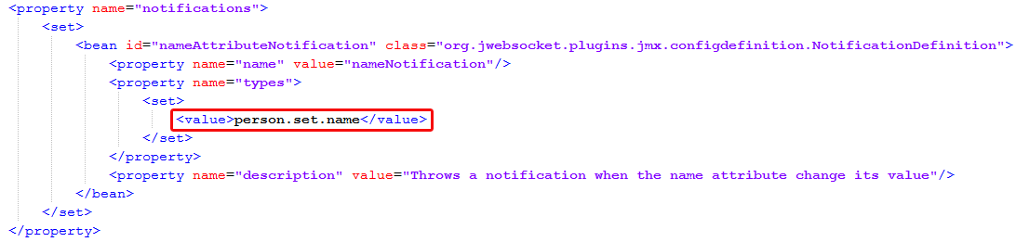
Fig. 16 Notifications property definition.
For each notification must be created a bean with an id given by the user and specify org.jwebsocket.plugins.jmx.configdefinition.NotificationDefinition in the class property. Then you must define the following properties:
- Name: contains the actual name of the event definition.
- Description: contains a brief description of the notification.
- Types: contains the type of notification that you want to launch. This property is a String array, so it is possible to define more than one notification type at a time. There are only three types of notifications that can be defined: set, before and after. Below are examples of how to define each of these notifications:
To define a notification that is thrown when the value of an attribute is changed, you must specify the value of the types property as shown below: DesiredName.set.AttributeName. For example if you want to create a notification for the name attribute of the Person class, the types property would be: person.set.name as shown in Fig. 16.
Moreover, to define a notification to be released before executing a particular method, you must specify the value of the types property as shown below: DesiredName.before.MethodName. In turn, to define a notification to be released after executing a particular method, you must specify the value of the types property as shown below: DesiredName.after.MethodName. Both notifications may be defined together as shown below:
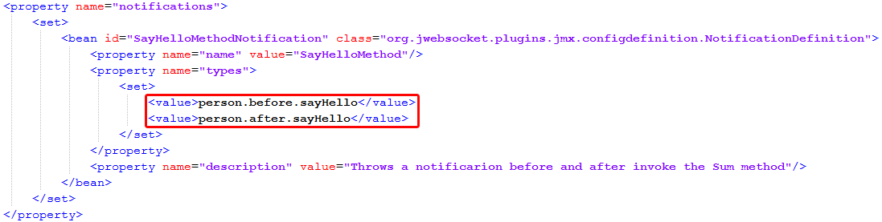
Fig. 17 Definition of the notifications before and after together.
In this way is possible to integrate any plug or class developed with jWebSocket framework into the JMX infrastructure of the module. It is important to note that if you make any mistake in the configuration file described above, instead of showing the desired MBean will be shown a MBeans whose names end with the word "Exception" indicating the error that was committed during the creation of the file.
JMXPlugIn module also enables access by using the HTTP protocol. Currently, the adapter used to access via this protocol is MX4J because it is open source. Basically, you should open a particular browser, and specify the domain that has been established for access to the module via HTTP, e.g. http://mydomain.com:8080. If you wish to access the module through a secure protocol you must specify in a particular browser: https:// mydomain.com: 8020.
In both cases to access to the functionalities of the module you must specify user and password. To avoid redundancy, will not be explained again the functionalities of the module because the names and the functioning of all the elements remain just as those mentioned above.
9. Settings
9.1 Default User Settings
To the access through RMI protocol, JMXPlugIn has a configuration file for authentication. The user “admin” with the password “jmxadmin” is defined by default. It provides access to the plugin without having to make any changes to the settings. However, due to the disadvantages in terms of authentication presents in MX4J adapter which is used to access the module through the HTTP protocol, isn´t possible use the same configuration file. Thus the default user defined for the access through this protocol is "admin" with the password "httpadmin" is important to note that the subsequent sections do not apply to MX4J adapter.
  - Modify Default User
To modify the configuration file for authentication, you must access to the folder that contains the jWebSocket server settings. Next you should edit the “jmxPluginConfig.xml” file located at the “JMXPlugIn” folder. This file contains the following default settings:

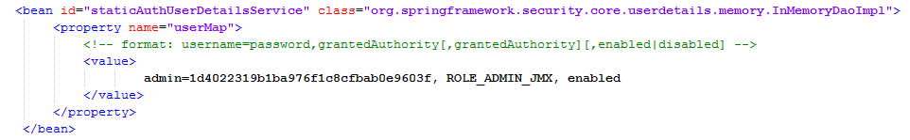
Fig. 18 Authentication section in the JMXPlugIn configuration file.

Note: for more information about the server folder structure you could access to the Folder Structure section.

To change the user "admin" you should take into account the following aspects:
- The password must be encrypted with MD5.
- The credential required for access to the module is "ROLE_ADMIN_JMX".
- The user must be enabled for authentication work properly.
  - Add a New User
To add a new user to the authentication module you must access to the settings mentioned above and add a new line with the desired values.
Example: To add a user “administrator" with the "ROLE_ADMIN_JMX" credentials. The configuration file must look like follows:
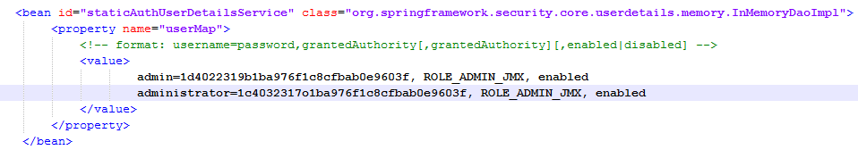
Fig. 19 New user added to the authentication section in the JMXPlugIn configuration file.

To add a new user you should take into account the following aspects:
- The password must be encrypted with MD5.
- The credential required for access to the module is "ROLE_ADMIN_JMX".
- The user must be enabled for authentication work properly.

10. Main Rules
R1: If the user wants to remotely access to the module via RMI protocol and does not correctly specify the desired URL, the system issues an error and not continue with the normal flow of events (see Fig. 11). Solution: The user must re-enter the URL for the module.
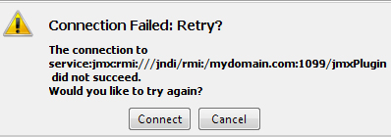
Fig. 20 Failed connection message.

R2: If the user wants to remotely access to the module via the RMI protocol and does not specify correctly the username and password required, the system issues an error and not continue with the normal flow of events (see Fig. 11). Solution: The user must re-enter the username and password required for remote access to the module.
R3: If the user attempts to invoke a functionality of a particular plugin and this method is not available for access from JMXPlugIn, the system displays an exception and not continue with the normal flow of events. Solution: The user before attempting to invoke a particular functionality must ensure that JMXPlugIn has access to it, which can be verified in the InformationOfRunningServers attribute belonging to the JMXPlugIn MBean.
R4: If shown in the list of available MBeans in the MBeanServer called jWebSocketServer (see Fig. 3), a MBeans whose name ends in "Exception" you will not be able to interact with this MBean, showing when deploying the MBean a description of the potential problem that caused that exception. Solution: The user must ensure that there aren´t any error in the structure of the configuration file pertaining to the mentioned MBean.

Remote Method Invocation
Hypertext Transfer Protocol
Message-Digest Algorithm
Monitoring tool with graphical interface compatible with JMX.

